Regularization Lambda: 0.6358245

Mean square error: 292.3615

1. 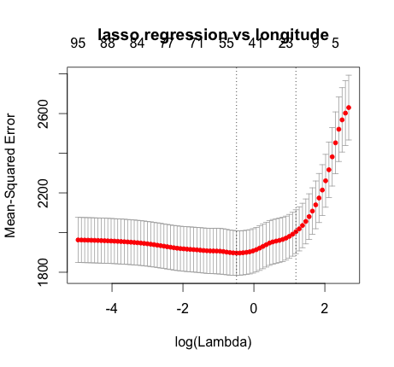

Regularization lambda: 0.803189

Mean square error: 1941.708

1. 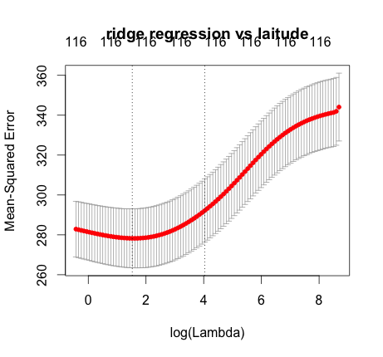

Regularization lambda: 9.663966

Mean square error: 291.0583

1. 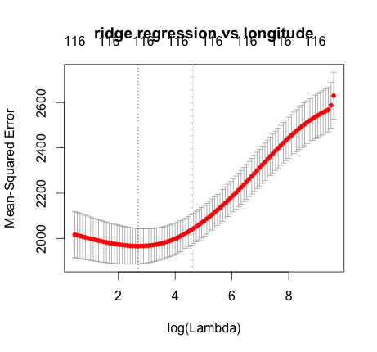

Regularization Lambda: 8.41335

Mean square error: 1889.012

1. 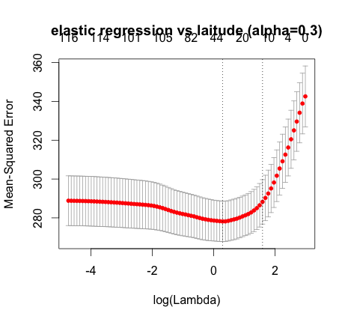

Alpha: 0.3

Regularization lambda: 1.759575

Mean square error: 291.5686

1. 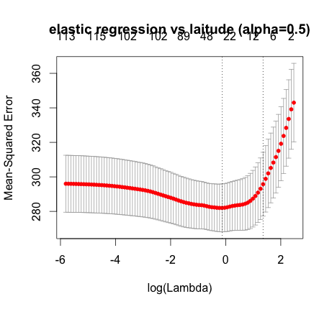

Alpha: 0.5

Regularization Lambda: 1.395633

Mean square error: 292.7855

1. 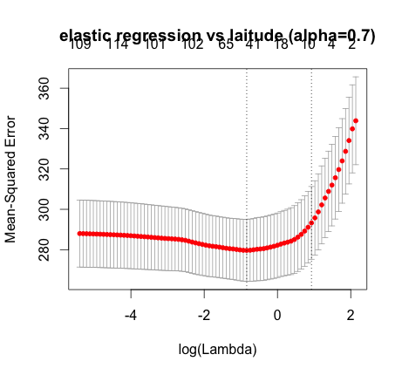

Alpha: 0.7

Regularization Lambda: 0.9083207

Mean square error: 292.3115

1. 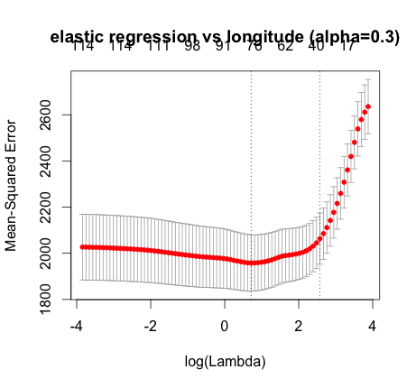

Alpha: 0.3

Regularization Lambda: 2.025277

Mean square error: 1927.69

1. 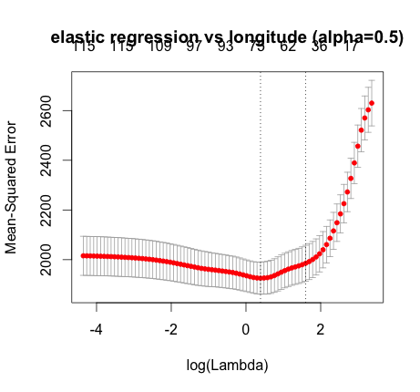

Alpha: 0.5

Regularization Lambda: 1.463672

Mean square error: 1935.508

1. 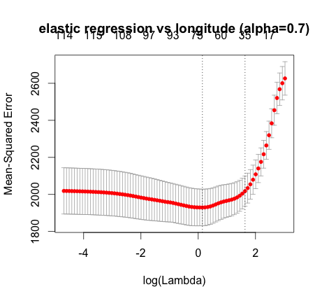

Alpha: 0.7

Regularization Lambda: 1.147413

Mean square error: 1940.48

Conclusion: Each regularized regression performed better than the ones without regularization. Ridge worked better in both latitude and longtitude.